**STATISTICS**

**ASSIGNMENT-3**

**EXERCISE 1.**

The Triple Blood Test screens a pregnant woman and provides an estimated risk of her baby being born with the genetic disorder Down syndrome. A study of 5282 women aged 35 or over analyzed the Triple Blood Test to test its accuracy.

A contingency table for Triple Blood Test of Down syndrome shown below.

|  |  |  |  |
| --- | --- | --- | --- |
| **Down** | **POS** | **NEG** | ***Total*** |
| D (Down) | 48 | 6 | ***54*** |
| Dc (unaffected) | 1307 | 3921 | ***5228*** |
| ***Total*** | ***1355*** | ***3927*** | ***5282*** |

1. Given that a test result is negative, show that the probability the fetus actually has Down syndrome is P(D | NEG) = 0.0015.
2. Is P(D | NEG) equal to P(NEG | D)? If so, explain why. If not, find P(NEG | D).

**SOLUTION 1.1.**

P(D | NEG) = P(D ∩ NEG) / P(NEG)

P(NEG) = 3927/5282

P(D ∩ NEG) = 6/5282

P(D | NEG) = P(D ∩ NEG) / P(NEG) = (6/5282) / (3927/5282) = **0,0015278838808251**

**SOLUTION 1.2.**

P(D | NEG) is **not** equal to P(NEG | D) because P(NEG | D) = P(NEG ∩ D) / P(D) and   
P(D | NEG) = P(D ∩ NEG) / P(NEG) here P(NEG ∩ D) = P(D ∩ NEG) but P(D) ≠ P(NEG).

So

P(NEG | D) = P(NEG ∩ D) / P(D)

P(NEG ∩ D) = 6/5282

P(D) = 54/5282

P(NEG | D) = P(NEG ∩ D) / P(D) = (6/5282) / (54/5282) = **0,111111111**

**EXERCISE 2.**

Males and females are observed to react differently to a given set of circumstances. It has been observed that 70% of the females react positively to these circumstances, whereas only 40% of males react positively -. A group of 20 people, 15 female and 5 male, was subjected to these circumstances, and the subjects were asked to describe their reactions on a written questionnaire. A response picked at random from the 20 was negative. What is the probability that it was that of a male?

P: pozitive, N: negative, M: male, F: female

P(P|F) = 0,7 and P(P|M) = 0,4

P(N|F) = 0,3 and P(N|M) = 0,6

P(M|N) = (P(N|M) x P(M)) / P(N)

P(N|M) = 1 - P(P|M) = 1 - 0,4 = 0,6

P(M) = 5/20 = 0,25

P(N) = P(N|M) x P(M) + P(N|F) x P(F) = 0,6 x 0,25 + 0,3 x 0,75 = 0,375

P(M|N) = (P(N|M) x P(M)) / P(N) = (0,6 x 0,25) / 0,375 = **0,4**

**EXERCISE 3.**

Answer the following questions by looking at the distribution table or coding with Python.

1. A salesperson has found that the probability of a sale on a single contact is approximately .3. If the salesperson contacts 10 prospects, what is the approximate probability of making at least one sale?
2. Ten coins are tossed simultaneously. Find the probability of getting  
   (i) at least seven heads  
   (ii) exactly seven heads  
   (iii)at most seven heads

**SOLUTION 3.1.**

We can solve this problem with binomial distribution. To find at least one sale we can 1-P(Zero sale)

If n=10, x=0, p=0.3, q=0,7 then P(Zero sale)=0,0282

P(at least one sale) = 1 - P(Zero sale) = 1 - 0,0282 = 0,971

**SOLUTION 3.2.i**

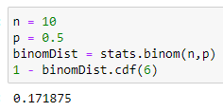

**SOLUTION 3.2.ii**

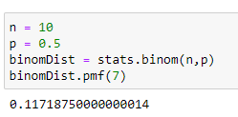

**SOLUTION 3.2.ii**

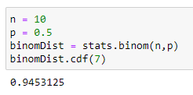

**EXERCISE 4.**

Answer the following questions by looking at the distribution table or coding with Python.

1. A type of tree has seedlings dispersed in a large area with a mean density of five seedlings per square yard. What is the probability that none of ten randomly selected one-square yard regions have seedlings?
2. Let Y denote a random variable that has a Poisson distribution with mean *λ = 2*. Find  
   (i) *P(Y = 4)*(ii) *P(Y ≥ 4)*(iii)*P(Y < 4)  
   (iv)P(Y ≥ 4 | Y ≥ 2 )*

**SOLUTION 4.1**

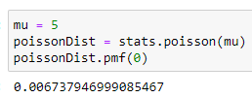

**SOLUTION 4.1.i**

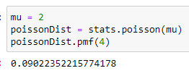

**SOLUTION 4.1.ii**

P(Y ≥ 4) = 1 - P(Y<4)

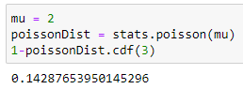

**SOLUTION 4.1.iii**

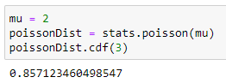

**SOLUTION 4.1.iv**

**EXERCISE 5.**

The cycle time for trucks hauling concrete to a highway construction site is uniformly distributed over the interval 50 to 70 minutes. What is the probability that the cycle time exceeds 65 minutes if it is known that the cycle time exceeds 55 minutes?

P(Y>65|Y>55) = P(Y>65 ∩ Y>55) / P(Y>55)

P(Y>65 ∩ Y>55) = P(Y>65)

P(Y>65|Y>55) = P(Y>65) / P(Y>55) = 0,25 / 0,75 = 1 / 3

**EXERCISE 6.**

The width of bolts of fabric is normally distributed with mean 950 mm (millimeters) and standard deviation 10 mm.

1. What is the probability that a randomly chosen bolt has a width of between 947 and 958mm?

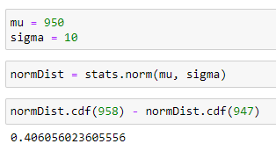

1. What is the appropriate value for C such that a randomly chosen bolt has a width less than C with probability .8531?

Z = (x - mu) / standard deviation

X = mu + Z x standard deviation

.8531 from Z table = 1.05

x = 960.5